**DEVELOP A PYTHON SCRIPT**

|  |  |
| --- | --- |
| TEAM ID | PNT2022TMID00923 |
| PROJECT NAME | Signs with Smart Connectivity for Better Road Safety |

**STEPS TO DEVELOP A PYTHON SCRIPT:**

**STEP-1:** Install Python IDLE 3.7 from any browser.

**STEP-2:** Open PYTHON IDLE. Click on File->New file. A new screen opens.

**STEP-3:** Develop a python program to satisfy the required needs.

**STEP-4:** Save the file and click Run-> Run Module.

**STEP-5:** The program gets executed and it reports any error if present, else produces the output.

**PYTHON CODE:**

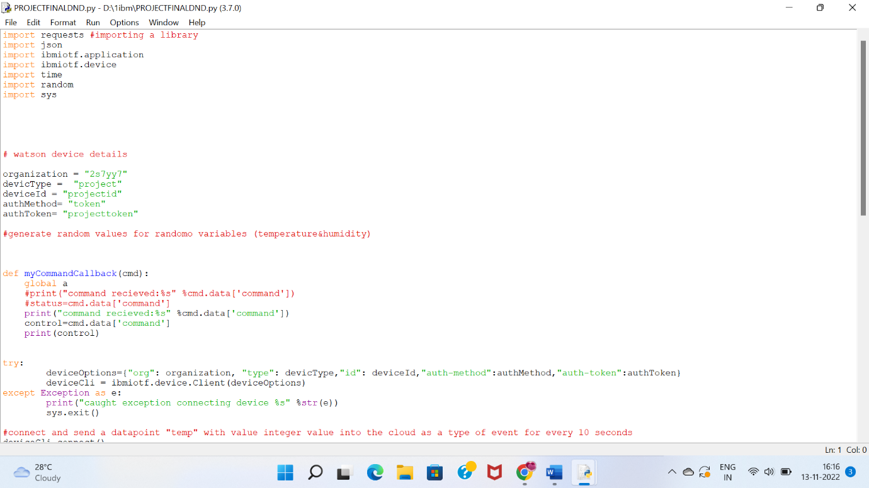

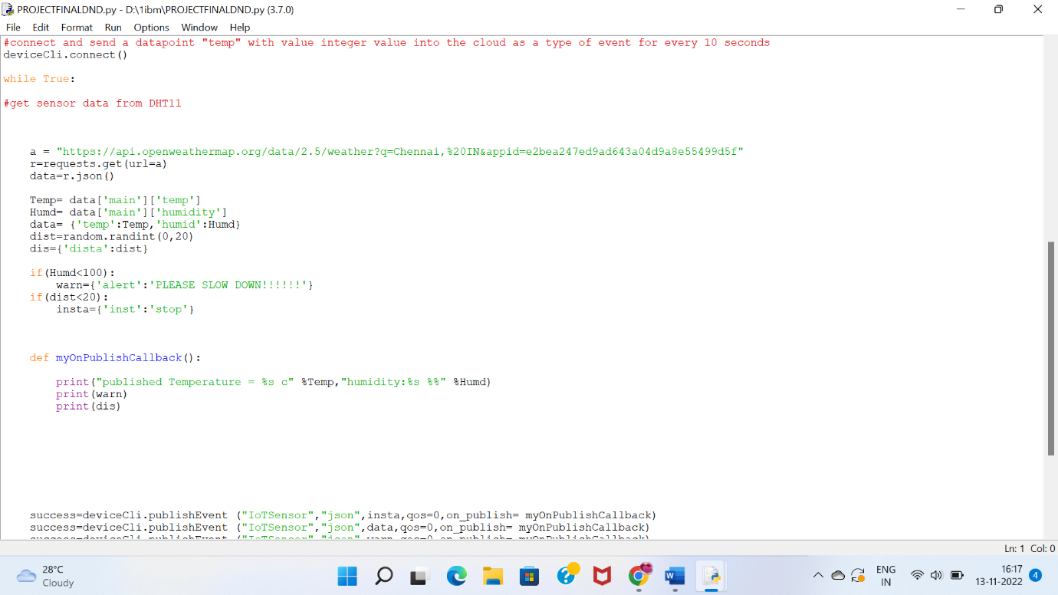

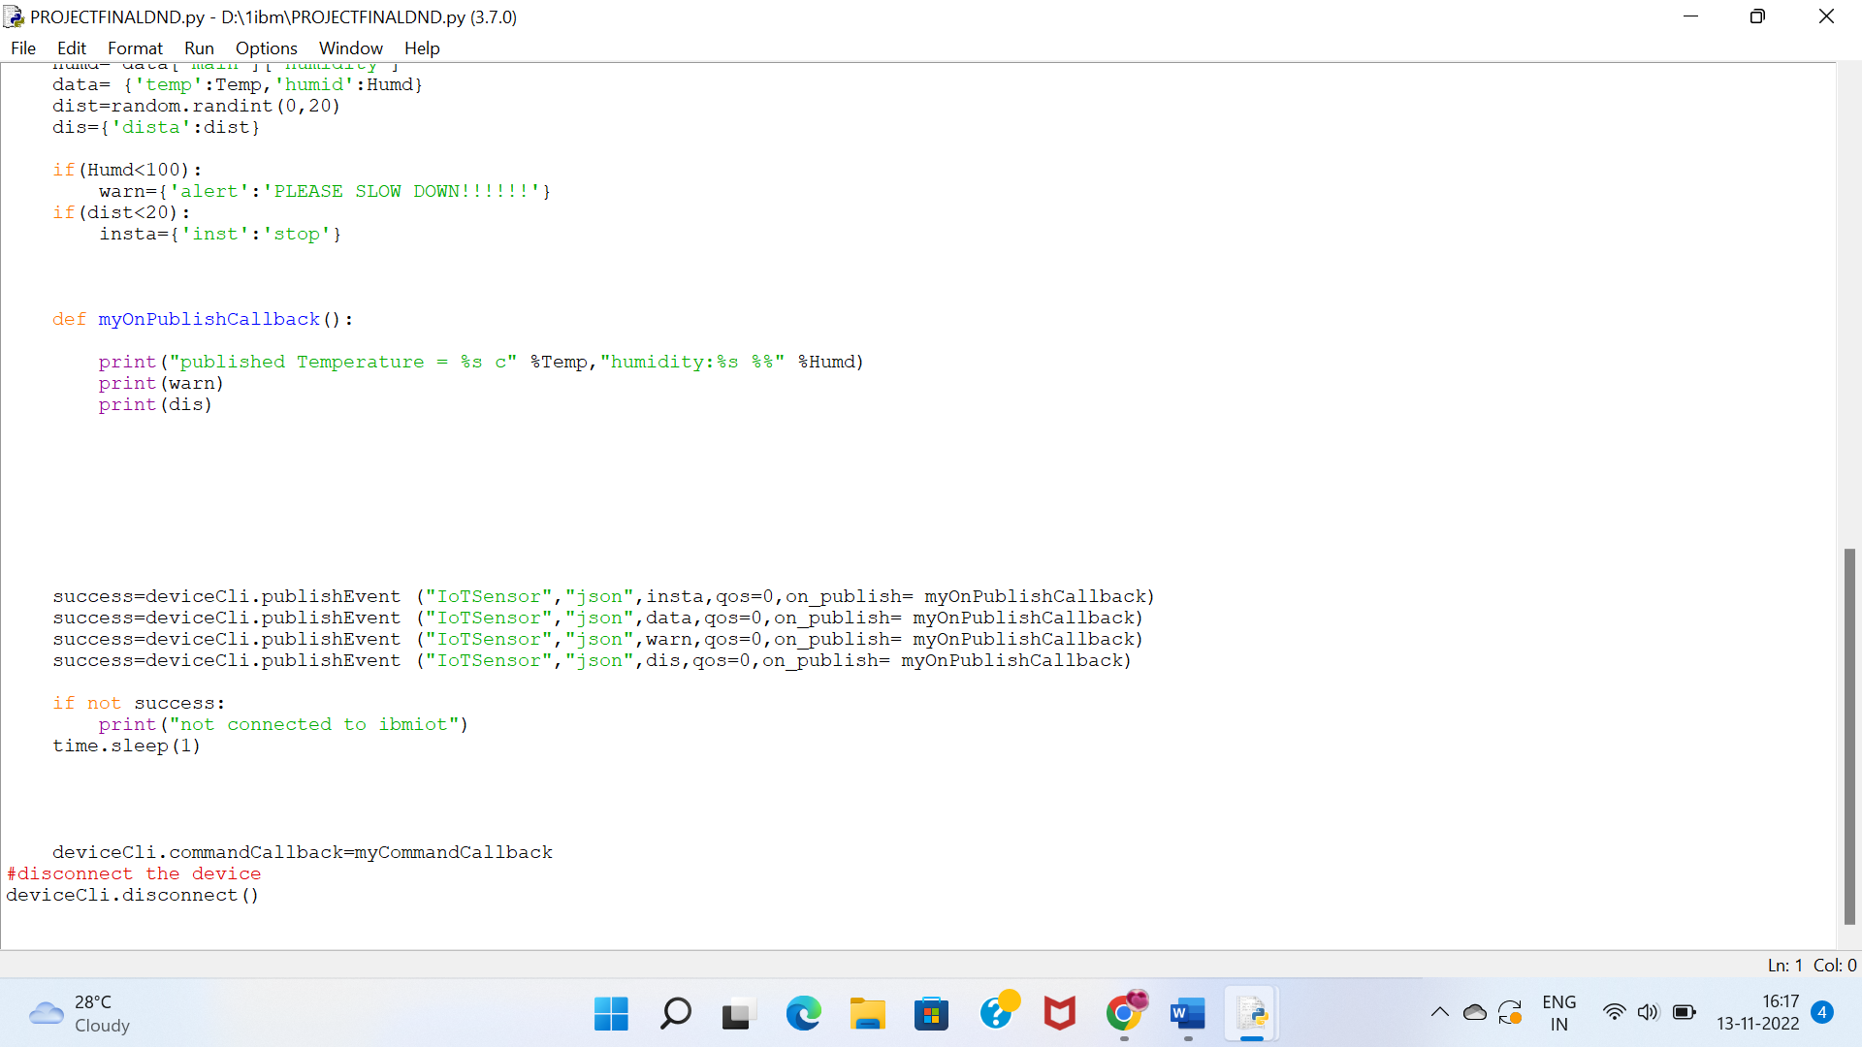

**OUTPUT:**

